Ex.No:17
Experiment : Write a Prolog Program to Sum the Integers from 1 to n
Aim
To write a Prolog program to find the sum of integers from 1 to n.
Objectives
- To understand recursion in Prolog.
- To calculate the sum of numbers from 1 to n.
- To display the result.
Algorithm
- Start.
- Read the value of n.
- If n = 0, return 0.
- Otherwise, add n to the sum of n−1.
- Display the result.
- Stop.
Program
sum(0,0).
sum(N,S):-
N>0,
N1 is N-1,
sum(N1,S1),
S is N+S1.
Sample Input
?- sum(5,S).
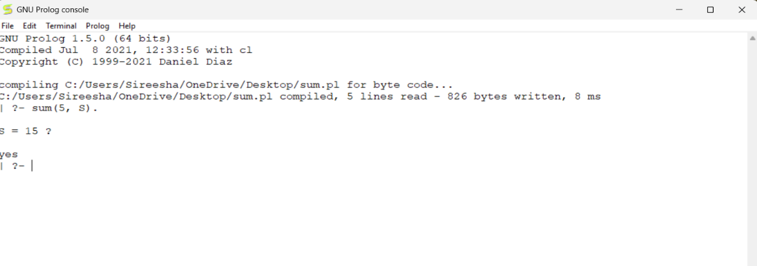
Output

Result
Thus, the Prolog program to find the sum of integers from 1 to n was implemented successfully.
Ex.No:18
Experiment : Write a Prolog Program for Name and DOB Database
Aim
To write a Prolog program to create a database containing Name and Date of Birth (DOB).
Objectives
- To understand Prolog facts.
- To create a simple database.
- To retrieve the stored information.
Algorithm
- Start.
- Store Name and DOB as facts.
- Enter a query.
- Display the matching record.
- Stop.
Program
person(ram,'10-01-2002').
person(sita,'15-08-2003').
person(ravi,'25-12-2001').
person(priya,'05-06-2004').
Sample Input
?- person(ram,DOB).

Output
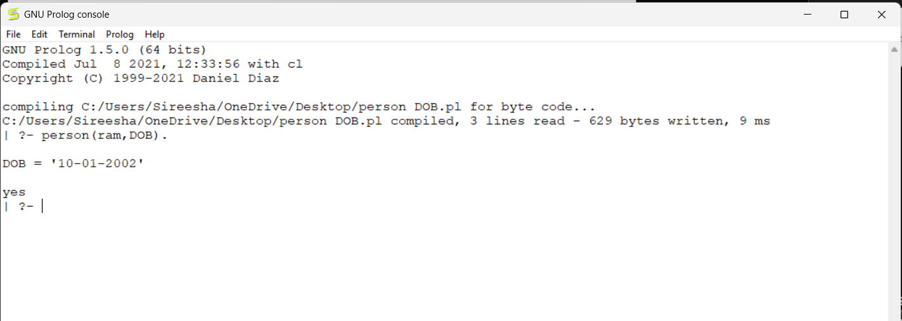

Result
Thus, the Prolog program to create a Name and DOB database was implemented successfully.
Ex.No:19
Experiment : Write a Prolog Program for Student–Teacher–Subject Code Database
Aim
To write a Prolog program to create a database containing Student Name, Teacher Name, and Subject Code.
Objectives
- To understand Prolog databases.
- To store student details.
- To retrieve teacher and subject information.
Algorithm
- Start.
- Store Student, Teacher, and Subject Code.
- Enter a query.
- Display the result.
- Stop.

Program
student_teacher(ram,ramesh,cs101).
student_teacher(sita,suresh,ai102).
student_teacher(ravi,mahesh,db103).
student_teacher(priya,anitha,cn104).
Sample Input
?- student_teacher(ram,Teacher,SubjectCode).
Output
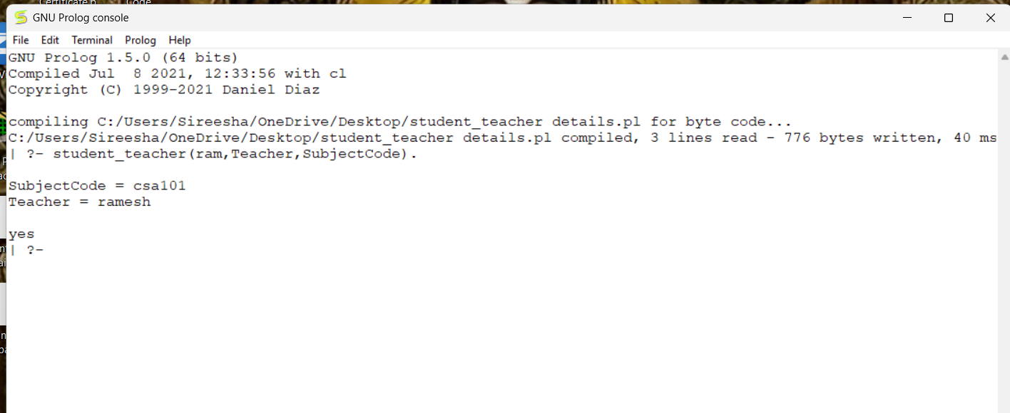
Result
Thus, the Prolog program for the Student–Teacher–Subject Code database was implemented successfully.
Ex.No:20
Experiment : Write a Prolog Program for Planets Database
Aim
To write a Prolog program to create a database containing the names of planets and their order from the Sun.
Objectives
- To understand Prolog facts.
- To create a planets database.
- To retrieve planet information.
Algorithm
- Start.
- Store planet names and positions.
- Enter a query.
- Display the required information.
- Stop.
Program
planet(mercury,1).
planet(venus,2).
planet(earth,3).
planet(mars,4).
planet(jupiter,5).
planet(saturn,6).
planet(uranus,7).
planet(neptune,8).
Sample Input
?- planet(earth,Position).
Output
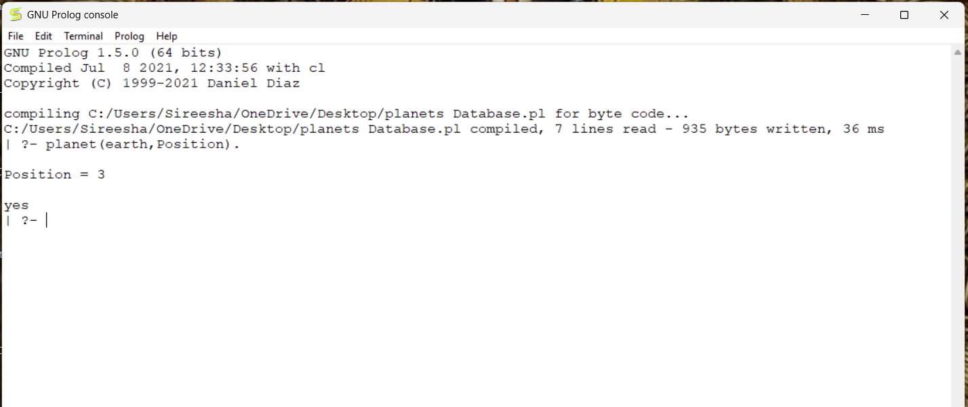
Result
Thus, the Prolog program for the Planets Database was implemented successfully.
Ex.No:21
Experiment : Write a Prolog Program to Implement Towers of Hanoi
Aim
To write a Prolog program to solve the Towers of Hanoi problem.
Objectives
- To understand recursion in Prolog.
- To move all disks from source to destination.
- To follow the rules of the Towers of Hanoi.
Algorithm
- Start.
- Read the number of disks.
- Move N-1 disks from source to auxiliary.
- Move the largest disk to destination.
- Move N-1 disks from auxiliary to destination.
- Stop.
Program
move(1,X,Y,_):-
write('Move disk from '),
write(X),
write(' to '),
write(Y),nl.

move(N,X,Y,Z):-
N>1,
N1 is N-1,
move(N1,X,Z,Y),
move(1,X,Y,_),
move(N1,Z,Y,X).
Sample Input
?- move(3,left,right,center).
Output
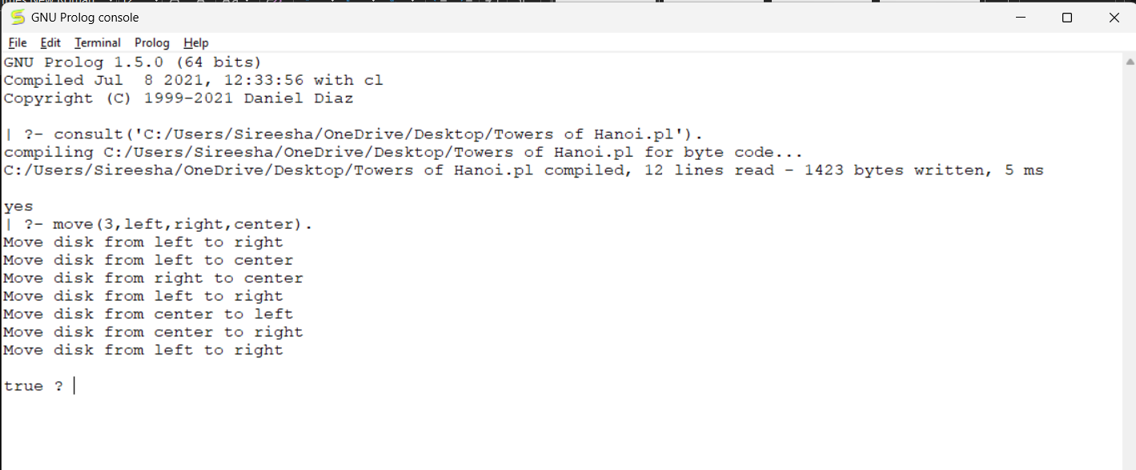
Result
Thus, the Towers of Hanoi problem was implemented successfully using Prolog.
Ex.No:22
Experiment 22: Write a Prolog Program to Print Particular Bird Can Fly or Not
Aim
To write a Prolog program to determine whether a bird can fly.
Objectives
- To understand facts and rules.
- To identify birds that can fly.
- To display the result.
Algorithm
- Start.
- Store bird names.
- Define birds that can fly.
- Query the bird.
- Display whether it can fly.
- Stop.
Program
bird(parrot).
bird(crow).
bird(pigeon).
bird(peacock).
bird(ostrich).
bird(penguin).

can_fly(parrot).
can_fly(crow).
can_fly(pigeon).
can_fly(peacock).
Sample Input
?- can_fly(parrot).
Another Input
?- can_fly(ostrich).
Output
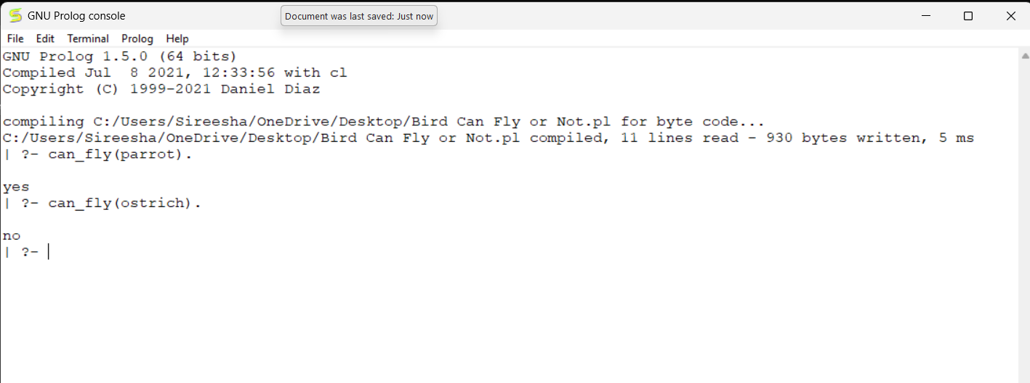
Result
Thus, the Prolog program to determine whether a bird can fly was implemented successfully.

Ex.No:23
Experiment 23: Write a Prolog Program to Implement Family Tree
Aim
To write a Prolog program to represent a family tree.
Objectives
- To understand family relationships.
- To implement parent relationships.
- To retrieve family information.
Algorithm
- Start.
- Store parent relationships.
- Define father and mother.
- Query the relationships.
- Display the result.
- Stop.
Program
father(ramesh,ram).
father(ramesh,sita).

mother(latha,ram).
mother(latha,sita).

parent(X,Y):-father(X,Y).
parent(X,Y):-mother(X,Y).
Sample Input
?- parent(ramesh,ram).

Output
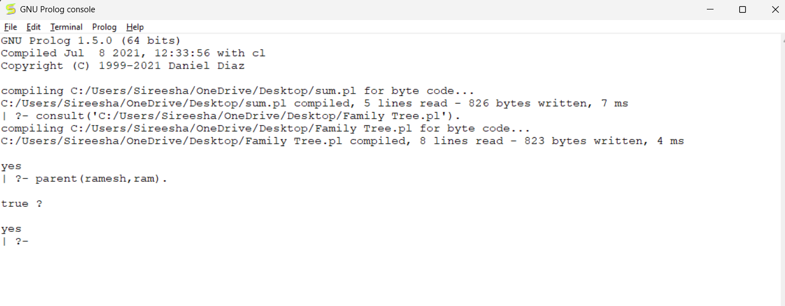
Result
Thus, the family tree was implemented successfully using Prolog.
Ex.No:24
Experiment : Write a Prolog Program to Suggest Dieting System Based on Disease
Aim
To write a Prolog program to suggest a suitable diet based on the disease.
Objectives
- To understand Prolog facts.
- To store disease and diet information.
- To suggest an appropriate diet.
Algorithm
- Start.
- Store diseases and diets.
- Enter the disease.
- Display the recommended diet.
- Stop.
Program
diet(diabetes,'Low Sugar Diet').
diet(bp,'Low Salt Diet').
diet(obesity,'Low Fat Diet').
diet(fever,'Liquid Diet').
diet(anemia,'Iron Rich Diet').
Sample Input
?- diet(diabetes,Diet).
Sample Output
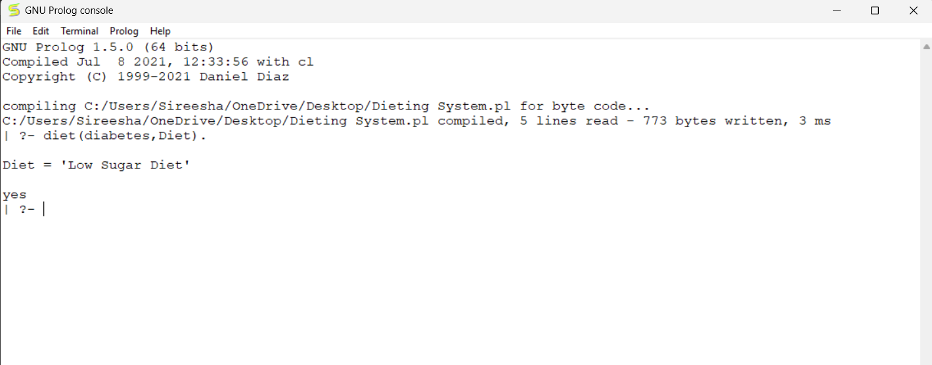
Result
Thus, the Prolog program to suggest a diet based on disease was implemented successfully.
Ex.No:25
Experiment : Write a Prolog Program to Implement Monkey Banana Problem
Aim
To write a Prolog program to solve the Monkey Banana problem.
Objectives
- To understand the Monkey Banana problem.
- To represent actions using Prolog.
- To determine whether the monkey can reach the banana.
Algorithm
- Start.
- Define the monkey's initial position.
- Define the box position.
- Move the monkey to the box.
- Push the box under the banana.
- Climb the box.
- Grab the banana.
- Stop.
Program
at(monkey,door).
at(box,window).
at(banana,center).

move(monkey,door,window).
push(box,window,center).
climb(monkey).
grab(banana).
Sample Input
?- grab(banana).
Output
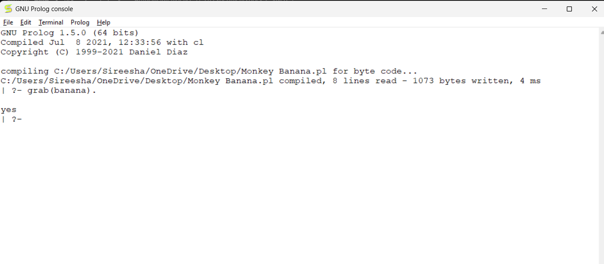
Result
Thus, the Monkey Banana problem was implemented successfully using Prolog.

Ex.No:26
Experiment 26: Write a Prolog Program for Fruit and Its Color Using Backtracking
Aim
To write a Prolog program to store the names of fruits and their colors and retrieve the information using backtracking.
Objectives
- To understand backtracking in Prolog.
- To create a fruit and color database.
- To retrieve fruit names based on color.
- To display all possible solutions using backtracking.
Algorithm
- Start.
- Store fruits and their corresponding colors as facts.
- Enter a query with a fruit name or color.
- Prolog searches the database.
- If multiple solutions exist, use backtracking to display all of them.
- Stop.
Program (Prolog)
% Fruit and Color Database
fruit(apple, red).
fruit(banana, yellow).
fruit(grapes, green).
fruit(mango, yellow).
fruit(orange, orange).
fruit(guava, green).
Sample Input 1
?- fruit(apple, Color).

Sample Input 2
?- fruit(Fruit, yellow).
Sample Input 3
?- fruit(Fruit, green).
Output
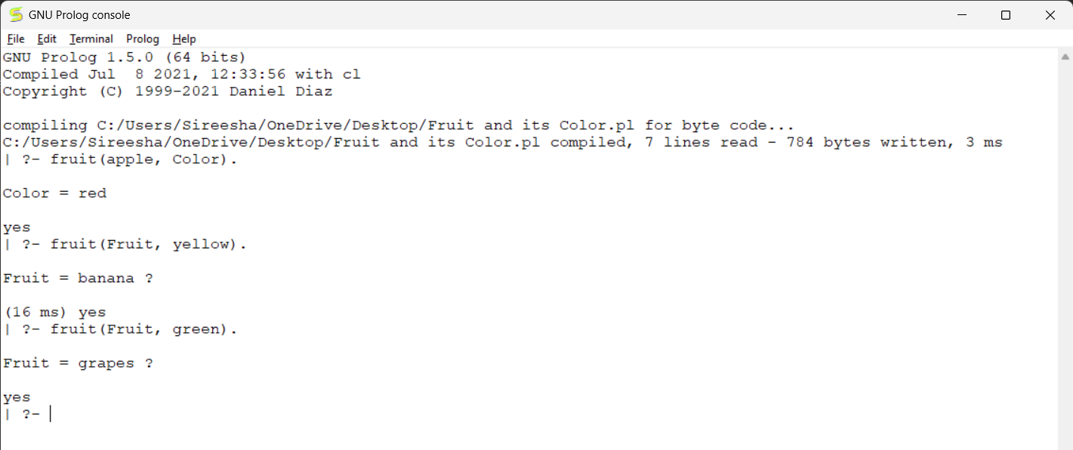
Result
Thus, the Prolog program for Fruit and Its Color Using Backtracking was successfully implemented. The program retrieved all matching fruits for a given color using Prolog's backtracking mechanism.

